Skill 01
Kasireddy Srihitha ~ 2520030153

1. Linux VM Setup
A Linux Virtual Machine was installed and configured as the development environment for the OSSP practicals. The terminal was opened and the Linux environment was verified using basic system commands such as uname -a, pwd, and ls.
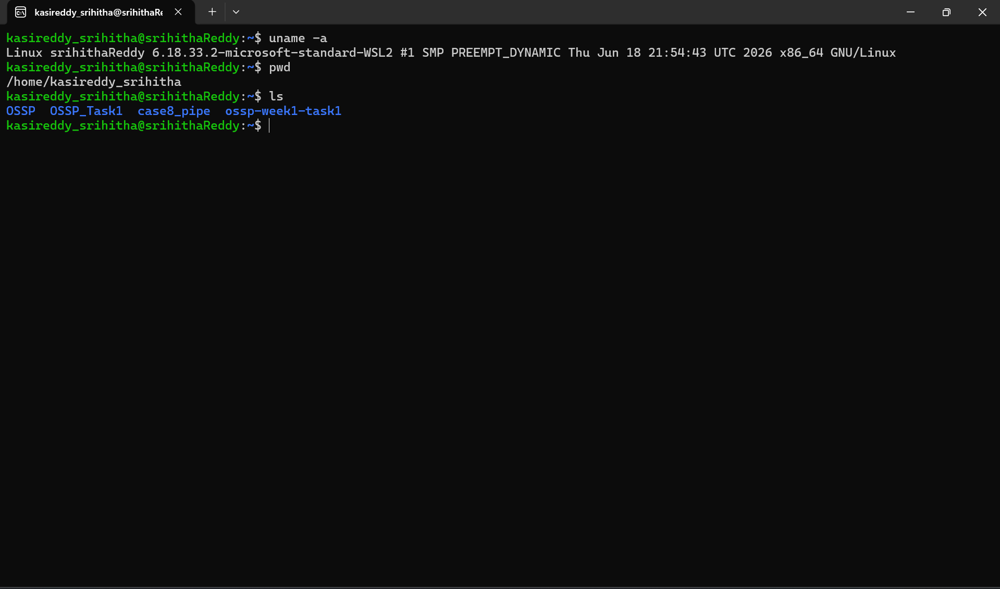Linux terminal showing the configured Linux environment.

2. GCC Configuration
GCC was configured for compiling C programs. The installation was verified using the gcc --version command. A simple C program was compiled and executed successfully to confirm that the compiler was working correctly.
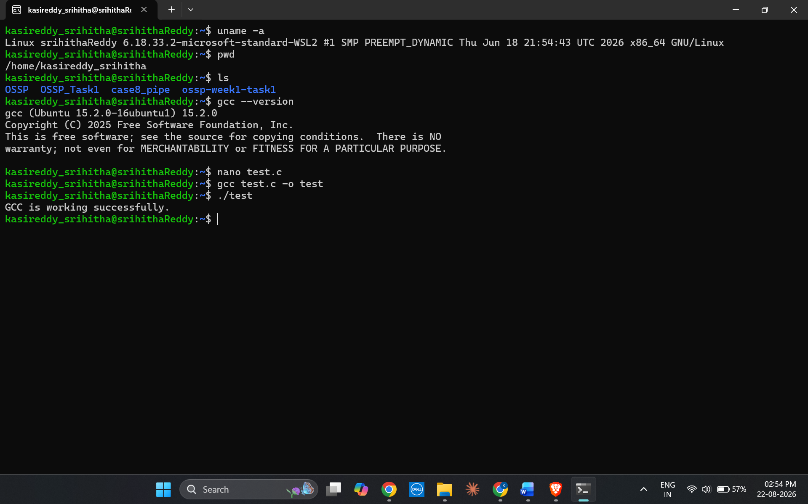
GCC version, compilation command, and successful program output.

3. Git Repository Setup
A Git repository was created to maintain the OSSP practical programs and project files. The repository was initialized, files were added, committed, and pushed to the GitHub repository.
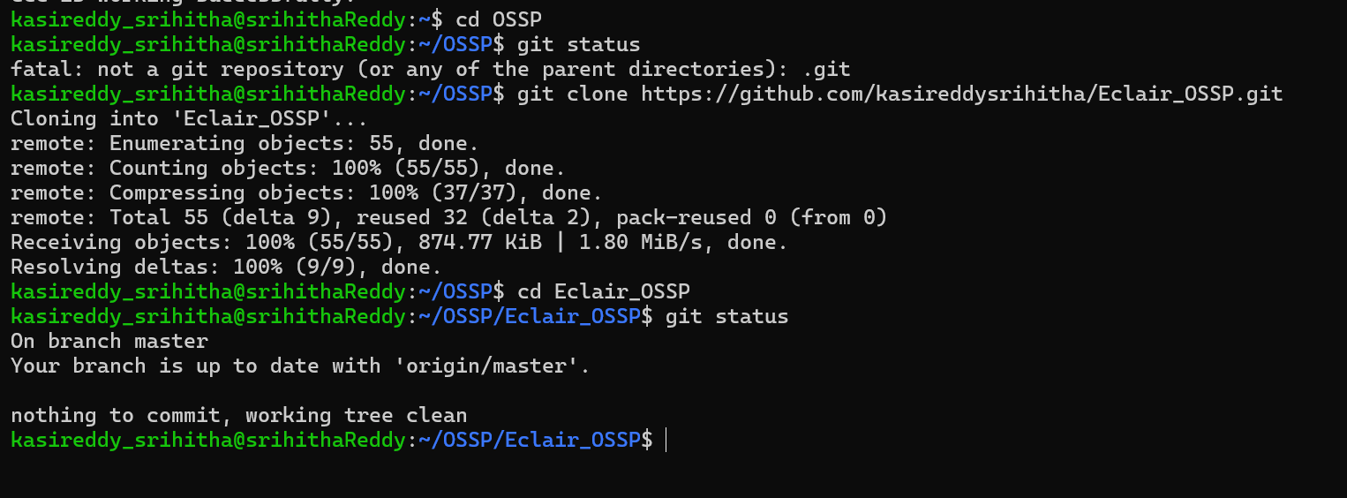
Git commands and GitHub repository showing the uploaded files.

4. Project Structure
The required OSSP project structure was created to organize practicals, skills, source files, and project components. Separate directories were maintained for source code and supporting files.
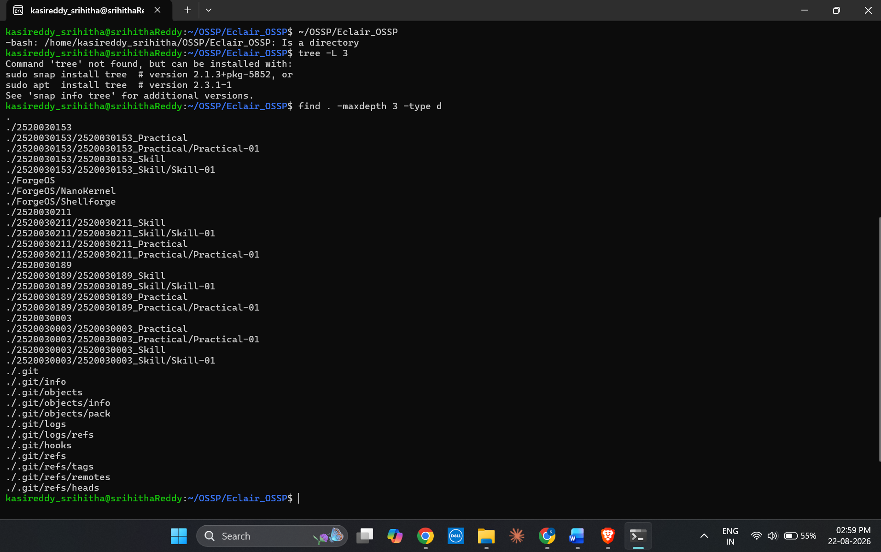
Project folder structure visible in VS Code or terminal.

5. Shell Architecture
The basic working architecture of a Unix/Linux shell was studied. The shell reads commands from the user, parses them, creates processes, executes programs, waits for completion when required, and displays the prompt again.
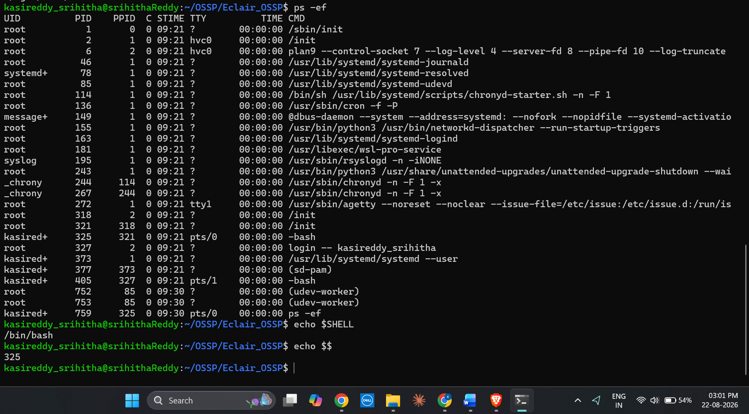
Shell architecture diagram / related implementation proof.

6. Initial Makefile
An initial Makefile was created to automate the compilation of C programs. The compiler and compilation commands were defined in the Makefile, and the program was successfully built using the make command.
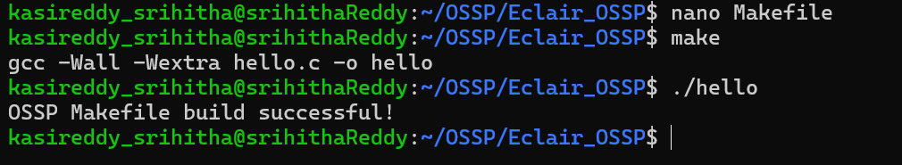
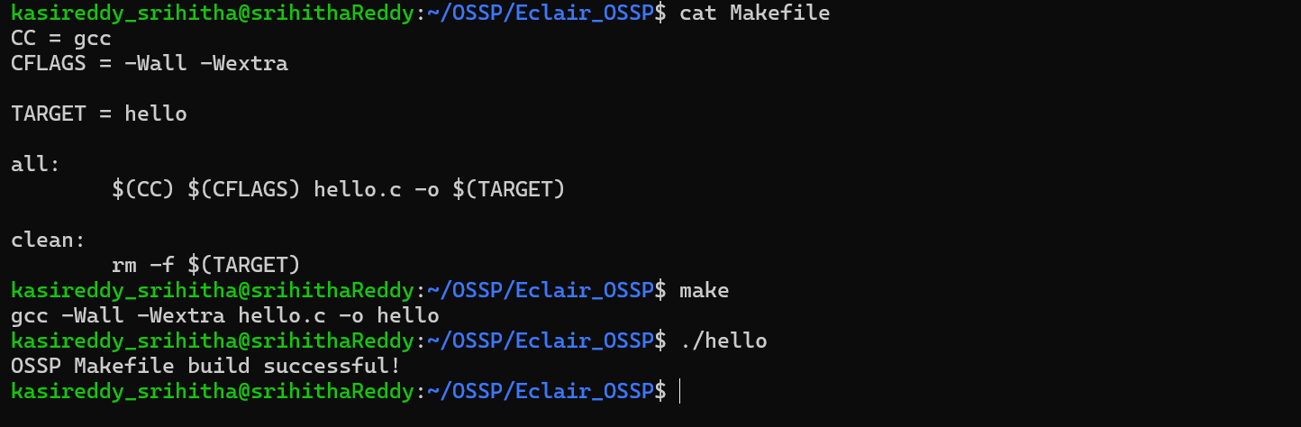
Makefile and successful make execution in the terminal.

7. Process Abstraction using fork()
The fork() system call was implemented to create a child process from the parent process. The process IDs were displayed to identify the parent and child processes.
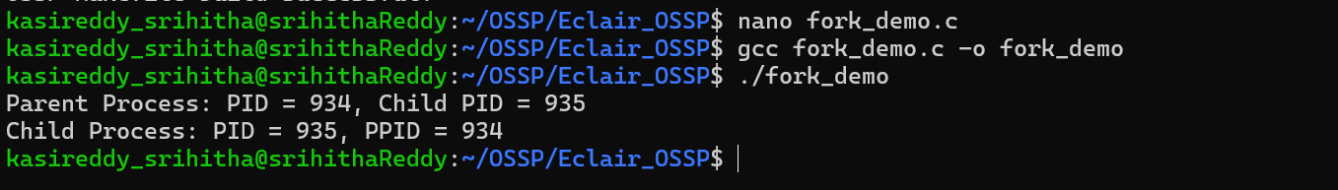
fork() source code and terminal output showing parent and child processes.

8. exec() Family
The exec() system call was studied and implemented to replace the current process image with another program. The execution was verified by running another Linux command through the exec() family.
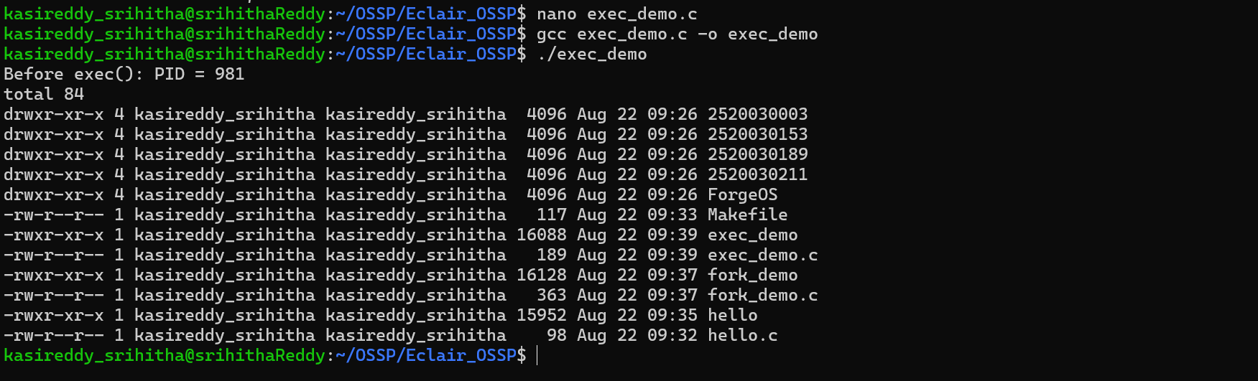
exec() source code and output showing the executed program.

9. Parent-Child Relationship
The relationship between parent and child processes was analyzed using process identifiers. getpid() was used to obtain the current process ID, while getppid() was used to obtain the parent process ID.
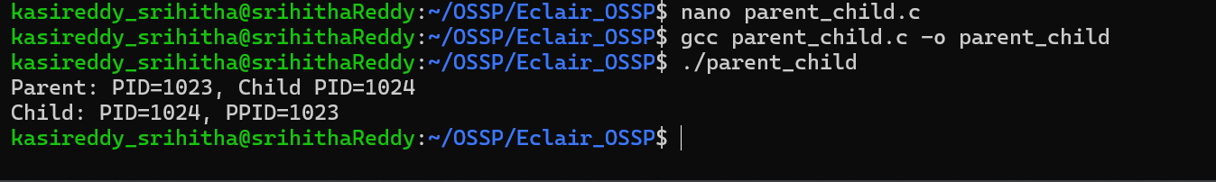
Terminal output showing PID and PPID.

10. Process Tree Analysis
The Linux process hierarchy was inspected using commands such as ps, ps -ef, or pstree. This helped identify the relationship between running processes and their parent processes.
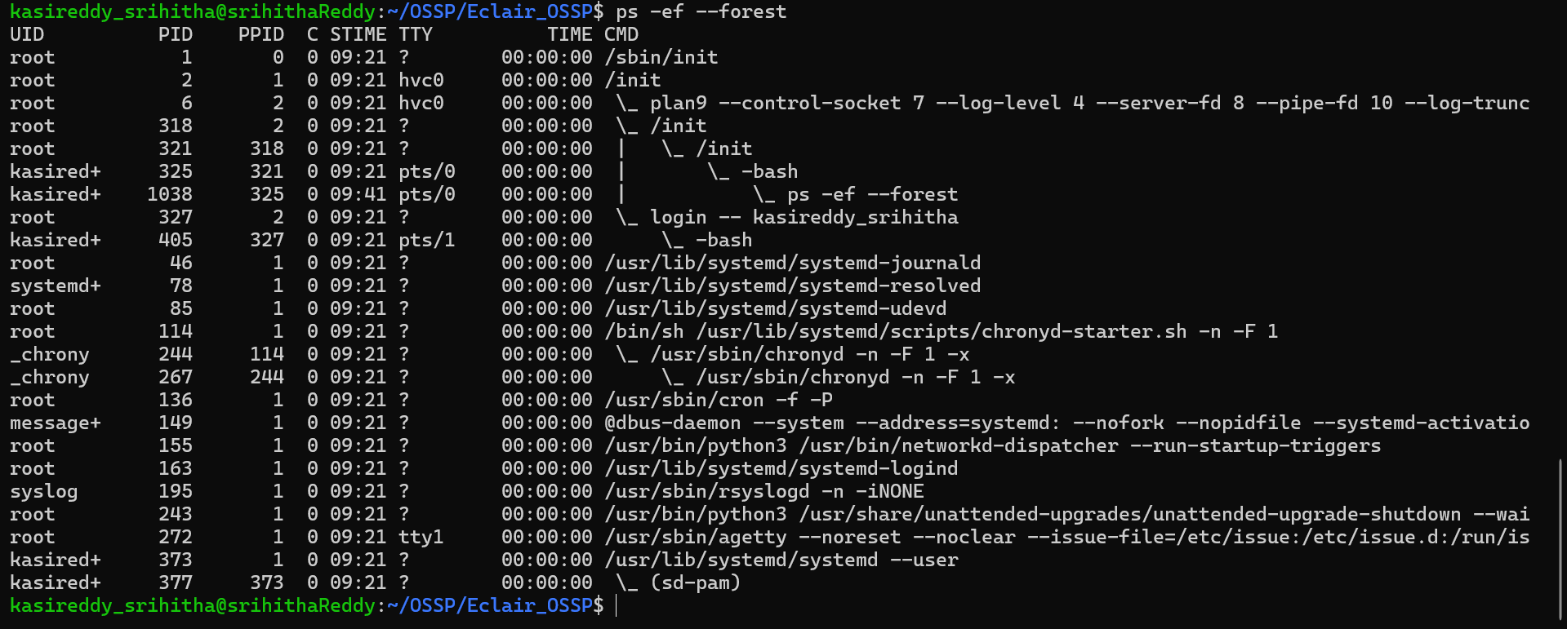
pstree or ps -ef output showing the process hierarchy.

11. System Call Tracing
System call tracing was performed using strace. The system calls generated during program execution were observed, including process-related calls such as execve(), fork(), and exit_group().
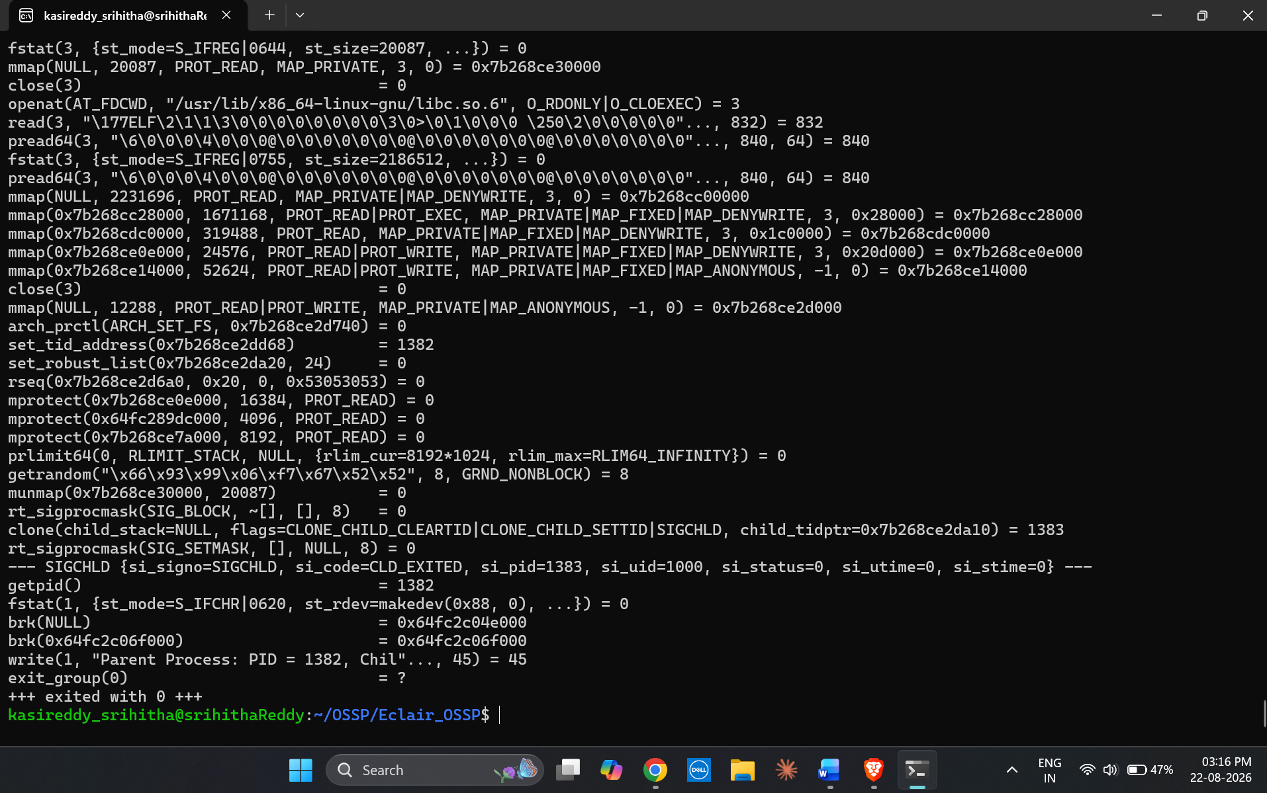
strace output showing the system calls made by the program.

Result
The Linux development environment was successfully configured, GCC and Git were set up, and the initial OSSP project structure and Makefile were created. Process creation using fork(), program execution using exec(), parent-child relationships, process trees, and system call tracing were successfully studied and analyzed.

